Against the grain

反常的食物价格

（英文部分选自经济学人20220827财经版块）

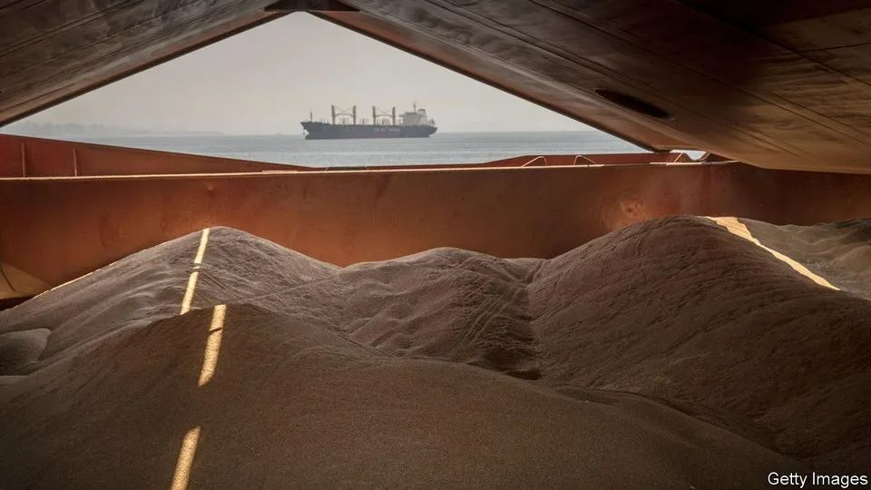

Against the grain

反常的食物价格

Global food prices have dropped to pre-war levels

国际食品价格已跌至（俄乌）战前水平

Six months after Russian tanks **rolled into** Ukraine, an inflationary shock is still **ripping through** boardrooms, finance ministries and households. But in one crucial area, prices have come back to Earth. The cost of grains, cereals and oils, staples of diets around the world, has returned to levels last seen before the war began.

俄乌冲突迄今已过半载，然而通胀对于政商金融、黎民百姓的冲击犹在。但在一个关键的领域，价格已经回归正常。谷物、谷类作物和食用油这些常规食品的价格已经回归至俄乌冲突前的水平。

Russia and Ukraine are agricultural powerhouses—until recently, the world’s largest and fifth-largest exporters of wheat and two largest exporters of sunflower oil. It was not, therefore, a surprise that food prices surged in February and March, driven by fears that exports would be disrupted by war; indeed, the worry was that shortages would persist, decimating grain stocks and causing mass starvation.

俄罗斯和乌克兰直到最近（在战争前）都是农业强国，分别是世界最大和第五大小麦出口国，在葵花籽油出口方面，更是稳坐前两把交椅。所以，因担忧战争会对相关出口造成中断，食品价格在二三月份的飞涨并不令人感到意外；是的，人们担忧这一问题将会持续一段时间，从而造成谷物储备大幅减少以及大规模饥荒的出现。

That terrible outcome now appears to have been been avoided. Last week wheat futures in Chicago, for delivery in December, dropped to $7.70 per bushel, far below the $12.79 they reached three months earlier and back to their level in February. Corn is also back to its pre-war price. Meanwhile, palm oil, found in thousands of dishes from ice cream to instant noodles, has dropped back not only to its pre-war price, but below it (see chart).

到目前看来，那样糟糕的结果似乎得以避免。上周，芝加哥12月交割的小麦期货价格已经跌到了7.7美金/蒲式耳，远低于三个月前达到的12.79美金，回落至2月的价格水平。玉米也同样回落至其战前的水平。同时，会在冰淇淋到方便面等上千种美食中使用的棕榈油，其价格甚至低于俄乌冲突前水平（见图表）。

The recent deal brokered by the United Nations, allowing Ukrainian grain exports to leave the port of Odessa, can only explain **a fraction of** the shift: it was signed in late July, after most of the decline in prices. More can **be credited to** the strength of Russian wheat exports. America’s agriculture department suggests that Russian farms, far from being disrupted, will export a record 38m tonnes in 2022-23, some 2m tonnes more than they managed the previous year. A bumper harvest is underway, **in part** due to good weather earlier in the year, and there is strong demand from traditional importers in north Africa, the Middle East and Asia.

得益于联合国协调的出口协议，乌克兰的谷物得以驶出敖德萨港，但这只是谷物价格下跌的部分原因：该协议与7月底签署，而此时谷物价格已经出现了大幅下滑。相比之下，俄罗斯小麦的强劲出口或是其中的主要原因。美国农业部表示，俄罗斯的农场出口不仅没有被影响，反而会在2022-2023年创纪录地出口3800万吨，相较前一年多出200万吨。天公作美，俄罗斯今年喜迎大丰收，而另一方面，北非、中东和亚洲等传统进口大户今年也需求强劲。

The worries about shortages may have been overstated in the first place. Charles Robertson of Renaissance Capital, an investment bank, argued at the time that cereal traders were overexcited—wrongly grouping together long-term disruption to oil-and-gas supplies and less plausible prolonged disruption to the food supply. “Global wheat stocks were extremely high,” says Mr Robertson, “which told us either that the relationship between stocks and prices had broken down or...that speculation had got ahead of itself.”

关于短缺的担忧可能一开始就被夸大了。投资银行Renaissance Capital的查尔斯-罗伯逊（Charles Robertson）当时认为，谷物交易商兴奋过了头，他们错误地将石油和天然气供给的长期中断和似乎不太可能的粮食供给长期中断混为一谈。他表示，“全球的小麦库存极其高，所以要么是库存和价格之间关系已经崩塌，要么……投机行为过于疯狂”。

The sheer volume of **speculation on** futures markets may also help explain the volatility. Michael Greenberger of the University of Maryland, formerly a division director at the Commodity Futures Trading Commission, a regulator, notes that rules limiting speculation are routinely avoided by American banks, which assign **swaps to** their foreign subsidiaries.

期货市场上大规模的投机交易也有助于解释这种波动性。马里兰大学的迈克尔-格林伯格（Michael Greenberger）曾是监管机构商品期货交易委员会的部门主管，他指出，美国的银行会将掉期交易交由其外国子公司进行，以此规避限制投机买卖的规则。

注释：1. thesheer volume of：数量庞大的。2. the Commodity Futures Trading Commission：The mission of the Commodity Futures Trading Commission is to promote the integrity, resilience, and vibrancy of the U.S. derivatives markets through sound regulation. 美国商品期货交易委员会（Commodity Futures Trading Commission，简称CFTC）是美国政府于1974年创办的独立机构，主要负责监管美国的衍生品市场，包括期货、掉期和某些种类的期权。3.CFTC的投机交易规避：具体可参考U.S. banks moved billions of dollars in trades beyond Washington’s reach 一文**https://www.reuters.com/investigates/special-report/usa-swaps/**）：The trades hadn’t really disappeared. Instead, the major banks had tweaked a few key words in swaps contracts and shifted some other trades to affiliates in London, where regulations are far more lenient. Those affiliates remain largely outside the jurisdiction of U.S. regulators, thanks to a loophole in swaps rules that banks successfully won from the Commodity Futures Trading Commission in 2013.

The drop in prices will not immediately feed through to consumers. Wheat and other cereal prices have returned to their pre-invasion levels when priced in dollars, but not in many other currencies. The greenback has climbed this year **on the expectation of** more rapid interest-rate rises by the Federal Reserve, leaving some emerging-market economies struggling. The Turkish lira is down by 27% against the dollar this year and the Egyptian pound is down 18%. The countries are two of the three largest wheat importers in the world.

消费者不会立刻感受到价格下降。以美元计价的小麦和其他谷物价格已经恢复到俄乌战争之前水平，但许多以其他货币计价的并没有。由于预期美联储将更快地提高利率，今年以来美元已经升值，这让一些新兴市场经济体陷入困境。土耳其里拉兑美元的汇率今年下跌27%，埃及镑兑美元汇率则下跌18%。而这两个国家位属世界三大小麦进口国之列。

Prices were high by historical standards even before the war, and there is no guarantee they will not rise again. Droughts across much of the world will affect crop yields. Meanwhile, fertilisers are still expensive. Urea, a compound used in the production of nitrogen-based ones, currently runs to $680 per tonne—down from $955 in mid-April, but still a lot more than the $400 it cost a year ago. That reflects the surging cost of natural gas, an ingredient in fertilisers. With fuel prices in Europe continuing to hit record highs, there may be more nasty surprises in store.

即使在俄乌冲突前，谷物价格也已处于历史高位，而且此后价格或会继续上涨。世界大部分地区出现的干旱会影响作物产量，同时化肥仍旧昂贵。尿素是一种用于生产氮基化肥的化合物，目前每吨价位在680美元，虽然相比4月中旬的955美元有所下降，但仍比一年前的400美元贵很多。这要归咎于作为化肥原料的天然气成本的飙升。随着欧洲燃料价格继续屡创历史新高，可能会有更多糟糕的意外将要发生。